Cluster Visualization and Labeling

Model Summary
- Algorithm: K-Means
- Number of clusters: 4
- Data used: Scaled training set (5,634 customers), using all 9 features (demographics, service usage, contract type, tenure, monthly charges)
- Model file: kmeans_model.pkl

Visualization
Since the clustering used 9 features, the results were projected down to 2 dimensions using PCA (Principal Component Analysis) purely for visualization purposes — the clustering itself was performed on the full feature set, not on the PCA output.
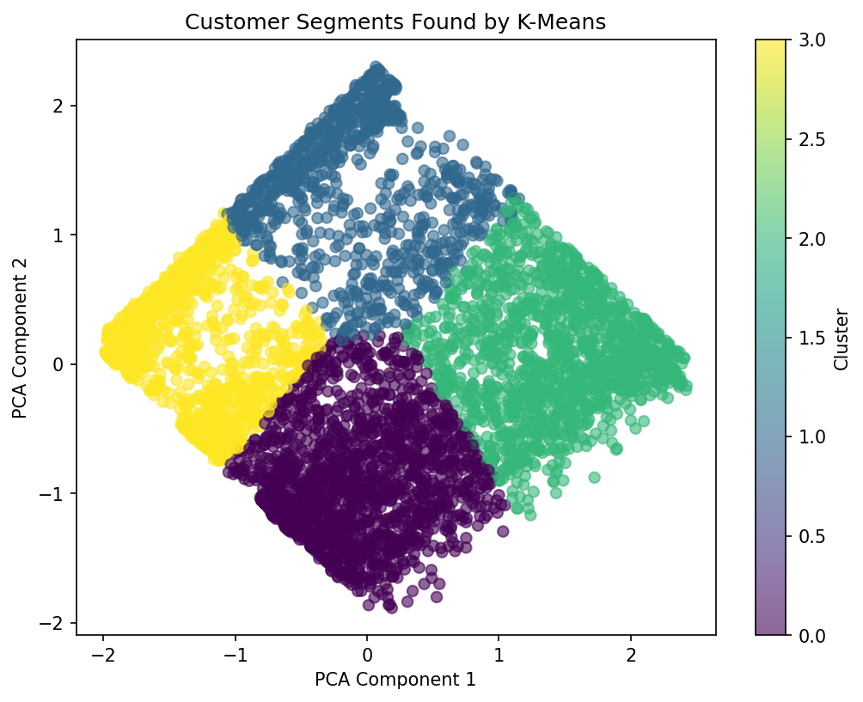
Figure 1: PCA scatter plot colored by cluster

Cluster Profiles
The table below shows the average tenure, average MonthlyCharges, and churn rate for each cluster, computed on the original (unscaled) values for readability:
Cluster | Customers | Avg. Tenure (months) | Avg. Monthly Charges | Churn Rate
0 | 1,775 | 14.86 | $81.07 | 49%
1 | 966 | 54.48 | $34.80 | 5%
2 | 1,512 | 58.72 | $93.75 | 16%
3 | 1,381 | 10.51 | $32.09 | 25%

Cluster Labels and Interpretation

Cluster 0 — "At-Risk New Customers"
Short tenure combined with high monthly charges. This group has by far the highest churn rate (49%) — nearly 1 in 2 customers in this segment leave. This is the highest-priority group for retention efforts.

Cluster 1 — "Loyal Low-Spend Customers"
Long tenure (over 4.5 years on average) with low monthly charges and the lowest churn rate (5%). These customers are on cheaper plans but have stayed the longest — a stable, low-risk segment.

Cluster 2 — "Long-Term High-Value Customers"
The longest average tenure combined with the highest average monthly charges, yet a relatively low churn rate (16%). This is the most valuable segment: customers who pay the most and also stay the longest.

Cluster 3 — "New Budget Customers"
The shortest average tenure and the lowest monthly charges. Churn (25%) is moderate — higher than the loyal segments but far lower than Cluster 0. These customers are new and on cheaper plans, so they haven't yet had the chance to prove long-term loyalty.

Key Insight
The clearest driver of churn risk in this data is the combination of short tenure and high monthly charges (Cluster 0). Customers who are both new and paying a premium price are far more likely to leave than any other segment, while long-tenured customers — regardless of how much they pay — churn much less. This suggests retention efforts should focus on new customers on higher-cost plans within their first year, potentially through onboarding offers, loyalty discounts, or proactive check-ins during the early months of the relationship.

